

**KidZone Learning Express**

**First Steps Preschool**

**Parent Handbook/Statement of Servies**

First Steps Preschool

3110 N. Hayden Road

Scottsdale, AZ 85251

(480) 949-5552

Updated March 2022

KidZone Learning Express, Inc dba First Steps Preschool offers full day programming for infants through six year olds, as well as before and after school care, and is licensed and regulated by AZDHS Office of Childcare Licensure. Inspection reports are available at 150 N 18th Ave Suite 400. We are covered with the necessary liability insurance to meet state requirements. Policy is available for review onsite.

***Non-discrimination Policies***



KidZone Learning Express, Inc and First Steps Preschool do not discriminate on the basis of a person’s race, color, religion, gender, national origin, sexual orientation, age, disability, Vietnam-era status, military family status or any other factors protected by law. This policy governs all aspects of the company’s operations.

***Mission Statement***

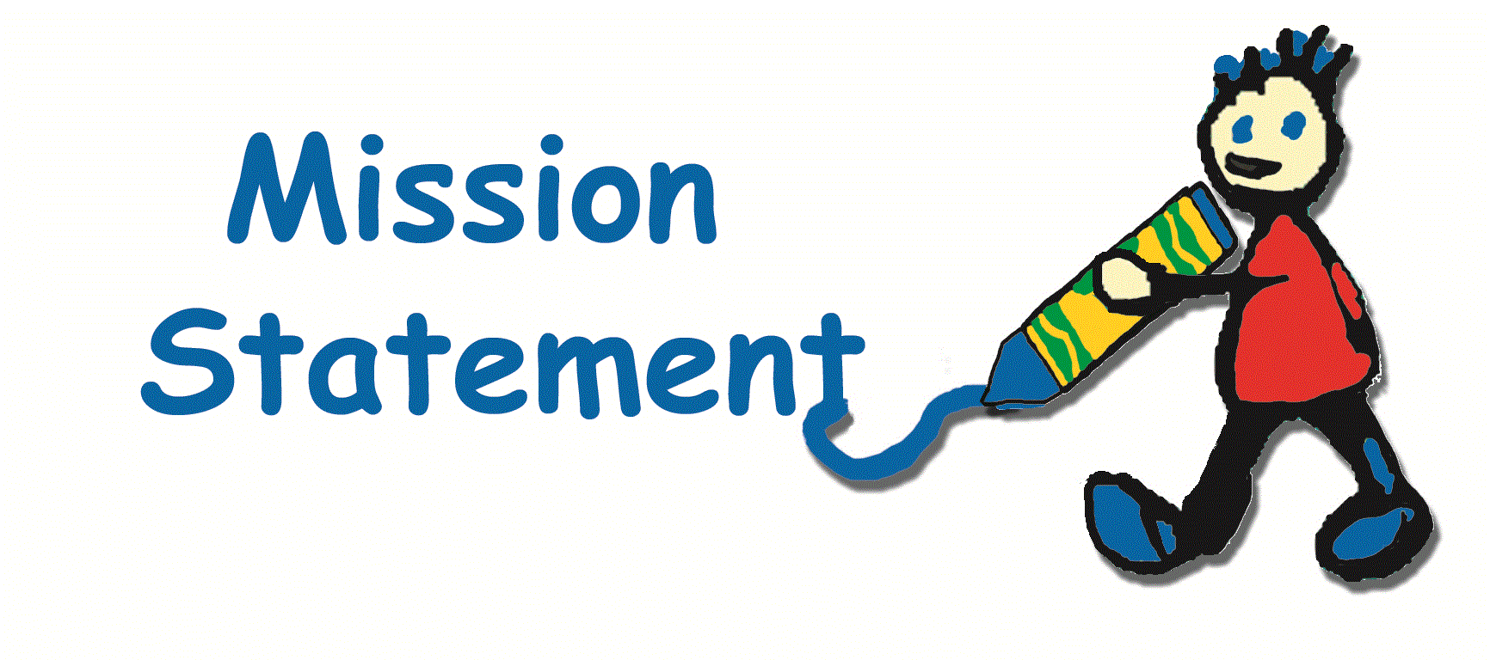

KidZone Learning Express, Inc. strives to meet the needs of our community by offering quality programming in a safe and positive environment where children can learn, grow and thrive.

***Philosophy***



We believe that the first few years of a child’s life are extremely important to future growth and development. A child’s time should be spent in an environment that is secure, stimulating, nurturing and fun. Children must feel safe to explore the world and try new things. Our primary goal is for each child to discover a love of learning and take with them a thirst for knowledge, a strong curiosity and the ability to work well with others.

***Communication***



Good communication is of the utmost importance. When a new family is accepted into our center, we like to be sure that we can share openly about any concerns or questions that may arise. It is important that there is a similar child care philosophy between the center and the parents. We welcome questions, feedback, or discussions of any kind that are oriented towards a positive outcome for the child(ren). Sensitive issues will be discussed in private at a mutually beneficial time.

***Hours of Operation***



Our center is open Monday through Friday from 6:30 a.m. to 6:00 p.m. for two’s and above, and 7:00 a.m. to 5:30 p.m. for Infants and ones. Children may not be dropped off between 10am and 2pm because it creates a disruption to our program. Please notify us by 10 if you plan to bring your child in at 2.

We maintain an open door policy for parents during the day. This means that parents may visit the center at any time, provided that your child does not have a problem separating when it is time for you to leave. We would appreciate your taking into consideration our schedule when dropping in, and remember that visitors usually cause children to react in an excited manner. If you call during the day, please be aware that we may be busy with the children and may not be able to answer the phone, so please leave a message and we will call you back.

***Center Rules***



There will be no running permitted in the center. Hitting, pushing, biting, grabbing, kicking, spitting, or pinching other children/infants/adults will NOT be allowed. No standing, sitting or climbing on tables. No standing on chairs or shelves. There will be no use of obscene, derogatory or disrespectful language.

Children are not permitted to walk around the center with food, cups or bottles. Respectful treatment of other people and all property, toys, and furniture is expected. Willful destruction of property will be charged to the parent at the cost to replace the item. Please support us in the enforcement of these rules, in order to create a better environment for all.

First Steps Preschool is a smoke-free environment in compliance with local, state, and federal laws. Please do not smoke while you are on the First Steps premises.

***Enrollment Policy***

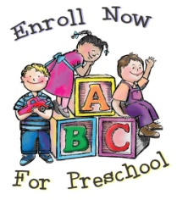

There are several forms that make up the KidZone enrollment packet. This enrollment packet must be completed and in our possession, and the first week’s tuition must be paid in full, before we can assume the responsibility of caring for your child. This is to ensure that your child will get the very best care possible and satisfies the record keeping requirement of state licensing guidelines. All forms will be reviewed annually. If there are changes to any of the forms in the enrollment packet, please notify the director to update your records. If you are not going to be at your usual place of employment, or at home, please make sure that we have a number where you can be reached.

Registration Fee: There is a $50 Annual Non-Refundable registration fee per child at time of enrollment and again each August. If you terminate childcare services you must re-register and pay a new $50 registration fee.

***Tuition / Payment Procedures***



Your specific rates are outlined in your Financial Agreement. We offer a 10% discount to families who enroll multiple children into our program. This discount is applied to the lowest tuition rate, and is only available when tuition is current. Tuition is payable in advance and is due no later than 6PM on Monday each week regardless if your child attends that day, unless another arrangement has been agreed upon. Payment must be made either by auto draft or through our online portal at Myprocare.com. There is no refund or proration of tuition due to a child’s absence for illness, holidays, or emergency closures of the center.

There will be a late fee of $10 for failure to pay by 6PM on Monday. Repeated late payments may be grounds for termination and parents who have not paid tuition by Wednesday morning of the week of care will be denied services until the account is made current. 15% interest will be charged on unpaid balances. A $20 per week late fee and a 50% collection fee will be added to unpaid balances requiring collection and/or legal services.

We ask you to consider how you would feel if your employer came to you on your expected payday and told you that your paycheck would be delayed? The success of our center depends upon the prompt payment of tuition/fees in order to take care of day-to-day expenses.

Third Party Reimbursement: Parents/guardians are responsible for any tuition or fees not paid by third party agency reimbursement. It is important that any changes that could affect your third party reimbursement are communicated to the Director in order to avoid additional fees and charges.

***Returned Payments***



If a payment through auto draft is returned for non-sufficient funds, there will be a $35 fee incurred, plus a $10 late fee. Services may be halted until full payment of tuition and NSF charges has been made. In addition, upon the second returned fee within 6 months, tuition must be paid in advance the previous week.

***Late Pick-up Fees***



A $1.00 per minute late pickup fee will be assessed for all children picked up after 5:30 pm for infants/ones and 6:00pm for children two and above. This must be paid in cash at the time of pickup, or before the child’s next regularly scheduled day. We would appreciate a call if you are going to be late, but a fee will still be charged. This will be strictly enforced, and habitual tardiness may result in termination of services.

If a child is left at the center after closing, staff will do the following:

#1. Try to contact you by phone

#2. Try to contact the emergency contacts

#3. If the above attempts are unsuccessful and the child has not been picked up 30 minutes past closing time, police or local authorities may be contacted.

***Parental Involvement***

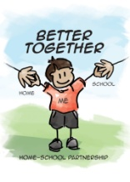

In addition to our open door policy, we welcome and encourage your involvement and input in the school’s programs. There are many activities in which parent volunteers are needed. You can lend objects for units of study, come and talk about your job, be a guest reader, help your child at home with the concepts we are studying, provide items for our parties, and join us for specially announced activities. Please see your child’s teacher for more information.

We want you to feel comfortable coming to us if you have concerns, questions or need clarification of any issues. We are partners in your child’s development! Parent Conferences are scheduled twice a year upon request, but Teachers and Directors are available to discuss your child’s progress or answer any questions you may have about our program at any time.

***Transportation***



We do not provide transportation except to and from specific elementary schools. Booster seat and signed authorization is required

***Arrival and Departures***



Children are to arrive clean and fed (unless arriving just before a meal time). We will try our best to send your child home with a clean diaper, and would appreciate the same consideration when you drop off.

It is normal for some children to have difficulty separating from parents, or cry when dropping off. Please make your drop off brief, the longer you prolong the departure, the harder it gets. A smile, cheerful good-bye kiss, and a reassuring word that you will be back is all that is needed. In my experience, children are nearly always quick to get involved in play or activities as soon as parents are gone.

Please be brief at pick-up times, as well. This is a time of testing, when two different authority figures are present (the parent and the provider). All children will test to see if the rules still apply. During arrival and departure, we expect parents to back up our rules. Please be in control of your child during pick up times. Drop off and pick up are not good times to discuss serious problems. Little ears and minds hear and understand everything. Your director can set up a time where the issues can be discussed in private.

Please leave your cell phones in your car so that the director, teachers and your child will have your undivided attention at pick up or drop off time.

Children will only be released to their parent/guardians and authorized people listed on your child’s Emergency Contact Card. Children will not be released to persons under the age of 18, including siblings, with the exception of minor parents. If someone other than the parent is to pick up the child, please notify us ahead of time. A verbal notice is fine on that day, if this person is on the list of people who are authorized to pick up your child. If the person is **NOT** on that list, we **MUST** have written permission to release your child. Please inform emergency contacts, or people designated to pick up your child, that if we do not know them then we will need to ask for identification. This is not meant to offend them. This is simply a measure taken for the child's protection.

For the safety of your child, you may be asked to call someone else to pick up your child if you appear to be under the influence or impaired in any manner.

***Sign In / Out***



Upon arrival and departure from the school, your child must be signed in and out using our Check-In station located in our office. This gives us a written record of the child's attendance, hours, and the person who brought/picked up the child each day. Please accompany your child into the classroom and place them with a staff member prior to leaving. Upon departure, please be sure a staff member recognizes that your child is leaving for the day.

***Absences***

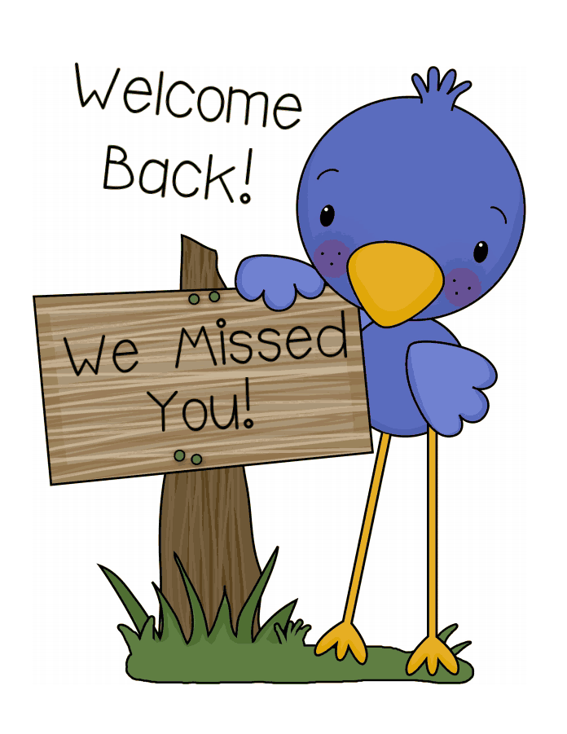  
As a courtesy, please notify the center if your child is going to be absent. Tuition is based on enrollment (a reserved space), not on attendance. We do not offer refunds, or make-up days for children who are ill or absent for any other reason.

***Illness***



First Steps Preschool is a "well-child care facility". At no time do we provide sick childcare. The following illness policies will be strictly enforced, for the health, well being and safety of all concerned.

Under no circumstances may a parent bring a child to school who shows any signs of illness or is unable to participate in the normal routine and regular program. Sick children will expose all children and staff members they come in contact with. Sick children want care from their parents in the comfort of their own homes. If other children become ill due to exposure to your sick child, either because he/she was returned to school before full recovery or because he/she was not picked up promptly upon notice of becoming ill, other parents will be unnecessarily inconvenienced. Because this is disruptive to other children and their families, your cooperation on this issue is extremely important. How would you feel if another parent brought their sick child and exposed your child? We STRESS this again -- if you are not sure whether or not it is okay to bring your child, please call ahead to ask us. We may require a doctor's decision as to whether or not the child is contagious. We appreciate you cooperation in this matter.

Every effort is taken to reduce the spread of illness by encouraging hand washing and other sanitary practices

**If your child is unable to participate in the normal activities of the program (including being able to play outside), then your child MUST stay home.**

Children will be visually screened when they arrive in the morning. In the event a child becomes ill and needs to be picked up, the parent(s) will be called and are expected to pick the child up within one hour (60 minutes). If the parent(s) cannot be reached, or have not arrived within an hour, the emergency contact person will be called and asked to pick the child up.

For the benefit of our staff and other children in our care, a sick child will not be permitted to return for 24 hours after condition has returned to normal. The child may return 24 - 48 hours (depending upon the illness) after they have received the first dose of an antibiotic. If a child receives an antibiotic for an ear infection, he/she may return to day care immediately if he/she has been free of other symptoms mentioned for at least 24 hours. If you aren't sure about whether or not to bring your child to care, please call to discuss. Allergy related symptoms, and non-communicable illnesses do not require exclusion if you have a note from your doctor.

We follow the Arizona Health Department guidelines for exclusion in preschool centers. Children with the following symptoms must stay home:

* Fever: Fever is defined as having a temperature of 100°F or higher taken under the arm (99.4° for infants) or 101°F taken orally. A child needs to be fever free for a minimum of 24 hours before returning to school, that means the child is fever free without the aid of Tylenol®, or any other fever reducing substance.
* Unexplained rash, earache, irritability, or confusion.
* Diarrhea: runny, watery, bloody stools, or 2 or more loose stools. When the child returns, they will be sent home after one loose stool.
* Vomiting
* Breathing trouble, sore throat, swollen glands, loss of voice, hacking or continuous coughing.
* Runny nose (other than clear), draining eyes or ears.
* Frequent scratching of body or scalp, lice, rash, or any other spots that resemble childhood diseases, including ringworm.
* Child is irritable, continuously crying, or requires more attention than we can provide without hurting the health, safety or well-being of the other children in our care.
* Other symptoms MAY be included if the director needs it necessary for the safety of others.

***Medications***



Parents will provide any prescription medications needed by the child, **in their original container with pharmacist's label, child's name, dosage instructions, current date, name of medication, and times to be administered clearly written.** Prescriptions must be current and can be given once per day once per day at lunchtime. Please bring medication to the office, and ask for a medication form in the office. **MEDICATION IS NOT PERMITTED IN CLASSROOMS!**

***Lice Policy***

From time to time you may be sent a notice that a child in our program has Lice. Lice are spread mostly by direct head-to-head contact, and have nothing to do with cleanliness or parenting skills. A suggested treatment program will be sent home should this happen, so please begin treatment as soon as you are notified of an issue, and your child will be checked upon returning to school. We have a **NO NIT POLICY** in order to stop the spread!

***Clothing / Attire***

      

Children should arrive dressed for play, wearing comfortable clothing appropriate for all activities throughout the day. Make sure to include hats, mittens, and coats for cold weather. Play is often messy, so please don’t send your child in nice clothing and expect them to be spotless at pick-up time. Shoes are to be closed-toed with a back (no slip-ons); tennis shoes are recommended.

Please bring at least 2 complete changes of clothing, including socks and underwear labeled with first and last name. We will not be responsible for lost items. If your child needs clothes and they do not have extra, we will call you to bring some to the school.

***Personal Items from Home***



Please do not bring toys from home. Little ones have a difficult time sharing with others, and it is even harder with their own special toys. We are not responsible for any loss or breakage of personal items. Items brought in smelling like smoke of any kind will not be used, and will be sent home.

Please label car seats, strollers, etc. with your child’s name. Stroller/carseat storage if available outside between our buildings. We are not responsible for these items.

***Meals***



KidZone Learning Express participates in the federally funded CACFP Program. Breakfast, Lunch and an Afternoon snack are offered free of charge for all children present during meal service hours. KidZone Learning Express is an equal opportunity provider. Children who arrive after meal times should be fed before they arrive. Breakfast is at 8:30am, lunch at 11:30am, and snack at 3:00pm. Menus will be posted on the bulletin board just inside the door. Copies of the menu are provided to parents upon request.

We prefer that children do not bring food, drinks, etc. from home unless requested. We will honor a parent's religious or philosophical objections to a menu item and the parent can substitute any objectionable item with an item from home.

If your child has allergies, and requires a modified diet, we must be notified of this in writing. **We will need to have a physician's written instructions describing any foods the child is not permitted to eat and a recommended substitution.** If a child has so many allergies that he/she cannot eat from our menu, we may require the parents to provide his/her lunch and snacks.

We never force a child to finish what is on his/her plate, but we do encourage each child to try one or two bites of everything. Sometimes they are surprised by what they like! All eating patterns will be communicated to the parents.

***Nap / Quiet Time***

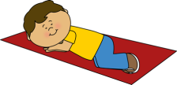

All children in our program will have a required rest time each day. Rest time gives children a much needed break during the day. Without rest time, some children are argumentative in the afternoon, short-tempered with others, and grumpy when they go home in the evening. Children should bring a small blanket labeled with first and last name that will be kept in their cubby, and only used for rest time. Please take your child’s blanket home every Friday to wash and return. Infants nap at varying times and their schedules will be accommodated. By 12 months children usually drop down to one nap per day.

***Outdoor Play***

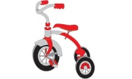

We will be playing outdoors every day except during extreme rain or heat advisories. Please make sure that your child is appropriately dressed for outdoor play at all times. During summer, outside times are cut down to 5 or 10 minutes at a time, and water activities are provided. We are mandated by state law to take the children outside. Parents who feel that their child is not well enough to participate in outdoor activities must keep them home until they are able to participate in all activities. Please apply sunscreen to your child during the summer months to ensure they do not get burned outside.

***Discipline***



We maintain a positive discipline policy, which focuses on prevention, redirection, and consistency. We stress two main patterns of behavior: respect for other people and respect for property. We believe that we should encourage good behavior by encouraging the right things, using clear and positive statements of behavior expectations, and redirecting behavior where appropriate. Time outs are not used for children under age 2 and are rarely used with other ages at all. We prefer to use a “time-away” philosophy to allow a child to separate from the group to regain composure.

Children sometimes hit, throw toys, bite, etc. We will try to prevent problems, redirect when appropriate, discuss inappropriate behavior, encourage making amends when offense involves another person, and sometimes withdraw privileges based on the principle of "natural and logical consequences". If there is any concern for safety of teachers or students, the child will be sent home or dis-enrolled immediately.

Under NO CIRCUMSTANCES will there be any spanking, physical abuse, verbal abuse, name calling or isolation used. Neither food nor sleep will ever be withheld from children as a means of punishment.

If a discipline problem arises that does not respond to the above mentioned techniques, we will hold a conference with the parents. Together, we will try to find a solution. You may be called to remove your child if his/her behavior prevents us from being able to properly care for the other children. If the problem continues, other arrangements for the care of the child will have to be made, for the safety and well-being of all.

***Biting***

Experts in the field of child development agree that biting is within a range of expected behaviors among children 12 months to 2 years of age. If a bite occurs, the teacher will attend to the bitten child with comfort, and clean the area with soap and water. Ice may also be applied. The biter will be removed from the immediate area, and placed away from the other children to play. Most children stop biting soon after these actions are taken. For children who continue to bite, it may be necessary to remove them from the school, either for a short period of time or permanently to ensure the safety and comfort of all staff and children. When a child bites more than once on a given day, the child’s parents will be called to immediately pick up the child in order to prevent further incidents and calm the biter.

Older children who bite will be sent home immediately.

Chronic biting may require that a child be suspended or withdrawn from enrollment for a period of time. If the child returns to the center, continues to bite, and is endangering the other children, the child may be terminated from the program.

***Holidays Closures***



We are closed in observance of the following holidays: New Year’s Day, MLK Day), Presidents Day, Memorial Day , Juneteenth, 4th of July, In Service Day before Fall Program, Labor Day, Veteran’s Day, Thanksgiving Day and the day after, Christmas Eve and Christmas Day. Tuition and fees are computed based on an annual cost, taking into account the days the center is closed; therefore, tuition is not adjusted for weeks with a closure day. *Subject to substitutions or additions depending on bank holidays*

If one of these holidays falls on a weekend, then we will be closed either Friday or Monday.

***Vacation***



After 6 months of enrollment, you may take up to 2 weeks (Monday-Friday) of vacation time per year without any charge. A Change of Program form must be turned into the office 1 week prior to your vacation. You may take additional vacation time; however, you will be responsible for tuition. No make-up days will be allowed for children who are absent. Children on scholarship ***may not*** be eligible for this benefit based on attendance requirements.

***Cleanliness / Hygiene***

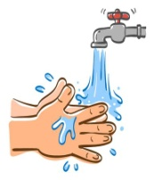 

We do our best to maintain strict cleanliness and hygiene standards. We ask for your assistance in making sure your child washes his/her hands at drop off. Children's hands are washed before and after meals and after toileting. All employees are required to wash their hands frequently and also use antibacterial gel.

Infants sleep in separate cribs, with clean sheets used only by them. Beginning at toddler age, washable nap mats or cots are used. Each child has a separate nap mat/cot with a sheet that is washed weekly (unless soiled, then they are washed as often as necessary) and mats/cots are wiped with disinfectant weekly.

Children use disposable cups, plates, bowls and eating utensils. High chair trays, tables, etc. are disinfected before and after each use.

***Fire Drills and Emergencies***



We are required by state law to do 1 fire drill per month. We vary the time of day to help the staff and children prepare to evacuate the building quickly and safely. If you are in the building during a fire or emergency drill, we ask that you follow our procedures and evacuate the building along with the children. Evacuation cribs with wheels are used to transport infants and non-walking toddlers to the emergency meeting area. Emergency evacuation procedures are posted in each classroom and Staff is trained to follow the evacuation map. Parents will be notified by telephone in the case of a serious injury, accident or center evacuation within 30 minutes, or as soon as reasonably possible.

***Medical Emergencies***



Minor bumps and scratches are inevitable, but we make every effort to keep the children safe through supervision and childproofing. Minor injuries receive appropriate first aid, and if an emergency injury or illness occurs, you will be contacted as soon as possible. If no one can be reached the child will be transported via ambulance to either the hospital specified on the Emergency Card or the hospital nearest our location. We will defer to trained medical personnel in any emergency situation to decide the best treatment for your child in your absence.

Parents are responsible for all costs involved in emergency medical treatment, including emergency transportation, if required. The owners of KidZone Learning Express, Inc. dba First Steps Preschool, will not be held liable for any sickness/injury of either parent/guardian or child while on these premises.

***Special Needs***

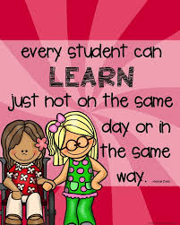

First Steps preschool complies with the Americans with Disabilities Act and applicable federal, state or local laws in providing services to children with disabilities. We will make reasonable accommodations to meet the special needs of children with disabilities in our program unless to do so would be a fundamental alteration of our existing program. We ask that you share with us information regarding your child’s physical, social, emotional and cognitive levels in order to assess our ability to meet the child’s needs.

***Potty Learning***



Each child develops and grows at his/her own rate and it is important to allow Potty Learning to happen on a timeline that works for your child. The child must be showing signs of readiness. These include showing interest in using the toilet, expressing discomfort when wet or dirty, having the ability to pull pants up and down alone, having words for pee and poo, telling you they are about to go or have already gone in their diaper, staying dry for longer than usual, and waking up from nap dry. When a child is ready, the process should go pretty quickly.

When your child’s teacher feels your child is ready for potty learning, we ask that you begin this teaching at home during a weekend or vacation. We will follow through and encourage your child while at school. The most important factor in successful Potty Learning is consistency, both at home and at school. The child must be kept in pull-ups or training pants at all times. Putting a child in diapers part time, and training pants part time, can be confusing and delay the training process. Please keep in mind that the activity level here can distract your child from responding to an urge to use the potty, more so than at your home. Therefore, we may continue to use pull-ups until your child can and will announce that he/she must use the bathroom (not just at home, but here, as well) and can control his/her bladder and bowels for a few minutes beyond that announcement.

During this process, we ask that the child be dressed in "easy off" clothing, as much as possible. Try to avoid really tight clothing, pants with snaps, buttons and zippers, and overalls. These are difficult for children to remove "in a hurry". The best items are shorts and pants with elastic waists, or dresses.

For children who are potty learning, we request at least five full changes of clothing, including socks, labeled with first and last name. All children will be supervised and offered assistance as needed. For health and safety reasons, all soiled clothes will be placed in a sealed plastic bag and sent home with the child at the end of the day-staff members will not rinse or wash items. Don’t be discouraged if we send home multiple wet bags of clothing each day! Accidents are an expected part of Potty Learning and it will take time for your child to recognize and control body signals. Accidents are a part of the learning process.

***Infants***



Infants are always fed on demand. Breast feeding infants need to have an adequate supply stocked and properly labeled. We do not wash bottles, so please bring enough clean bottles and nipples to last the whole day. They will be sent home to be cleaned.

A report will be prepared for each infant/toddler each day. It will include things such as, time of feedings, what was eaten, amount eaten, time of diaper checks and results, times of naps, any medication given, and various comments about the child's day.

Safe Sleep Position: Pursuant to the recommendations of the American Academy of Pediatrics, we place infants on their backs to sleep. If you request your child to be placed in a different position, a written note from your child’s physician documenting a specific medical condition is required.

**What Do I Need To Bring On The First Day?**

The following are lists of items according to your child’s age group that you should have for your child’s first day of school. Please remember to label all personal items with your child’s first and last name.

**(Infants)**

_Swaddler/ Sleep Sack

_Extra Clothes

_Bibs

_ Breast Milk labeled with full name, amount, and date AND/OR

_Bottles- Labeled with full name, enough for the day plus one extra

_Formula, bottled water (we can provide tap water)

_Sippy Cup

_Baby Food and Cereal

_Snacks

_Diapers

_Baby Wipes

_Pacifier

**One’s /Young Two’s**

_Small Blanket for Napping

_2 Changes of Clothing

(Should include underwear, socks, shirt, pants or shorts)

_Diapers & Wipes

_ 2 Sippy Cups one for milk and one for water

**(Two’s)**

_Small Blanket for Napping

_2 Changes of Clothing (More for Potty Training)

(Should include underwear, socks, shirt, pants or shorts)

_Diapers/Pull-Ups & Wipes

_ Reusable Water Bottle

**(Preschool 3’s )/ Transitional Kindergarten 4’s)**

Small Blanket for Napping

_1 Change of Clothing

(Should include underwear, socks, shirt, pants or shorts)

_ Reusable Water Bottle

Updated June 2020

***Photographs/Digital Image Release***



In order to document achievements and milestones we often take pictures of the children. You give permission for your child to be photographed or have digital images taken for school use.

***Reporting Requirements***



As a child care center we are mandated reporters and have an obligation to report suspected abuse or neglect to the appropriate state agencies. Failure to report can result in staff being charged with criminal penalties. Always be sure to let your director know when you drop your child off if he/she has any unexplained cuts or bruises. All children that come to school with injuries will have them logged into the child's file.

We understand new laws allow the use of medical marijuana; however, if staff suspect that you are under the influence, you may not be permitted to drive your child home.

***Termination and Withdrawal Policies***



First Steps Preschool may decide to terminate enrollment for non-payment of tuition, behavior issues by the child or parent, failure to comply with handbook policies, the inability to meet the child’s needs, or the inability to meet the parent’s expectations. This list is not all inclusive and we reserve the right to dis-enroll anyone at any time, with or without notice, and with or without reason.

Parents are required to give two weeks written notice when they decide to terminate child care. The two weeks will be paid in full, regardless of whether or not the child is in attendance. If proper notice is not given, tuition will still be due regardless of your child’s attendance. Unused vacation weeks may not be used during this period.

Anyone who withdraws and has a balance that is outstanding will need to have the account settled within 30 days. All accounts not settled within 30 days will be turned over to a collections agency regardless of amount owed. All accounts turned over to collections or processed through the legal system will have a $20 per week late fee plus 50% collections fee added to amount due.

***Revisions to Handbook and Contract***

There will be a yearly revision to this handbook and the accompanying contract. All families will sign a new contract each year. We reserve the right to make changes in rates and policies as we deem necessary. You will be notified, in writing, of any changes that may occur. Every attempt will be made to give at least a two week notice of changes.

KidZone Learning Express, Inc First Steps Preschool Parent Handbook

Acknowledgement and Receipt Form

By signing this form, I agree that I have received a copy of the Parent Handbook. I further agree that I have read and understand all policies and procedures set forth in the First Steps Preschool Parent Handbook.

________________________________ _________________________

Parent/Legal Guardian Signature Date

________________________________ _________________________

Parent/Legal Guardian Signature Date

________________________________ _________________________

Center Director Signature Date